Daniel Palumbo

Homework0

1 & 2). Java version and compiler versions

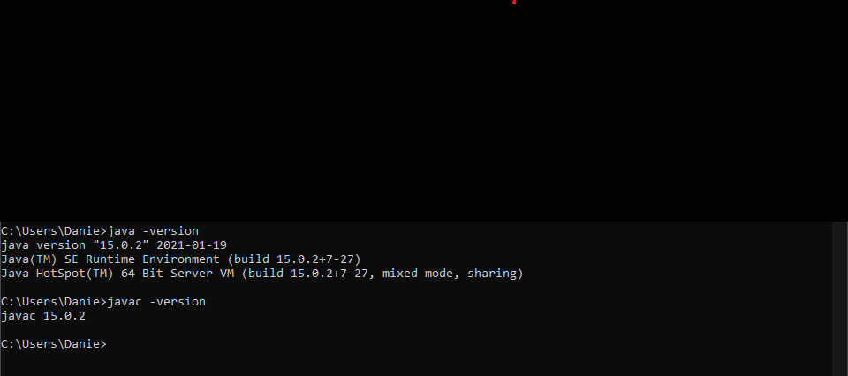

3.) Photo of my Github account, I did end up making a new one for this class because my other one is linked to my personal email.

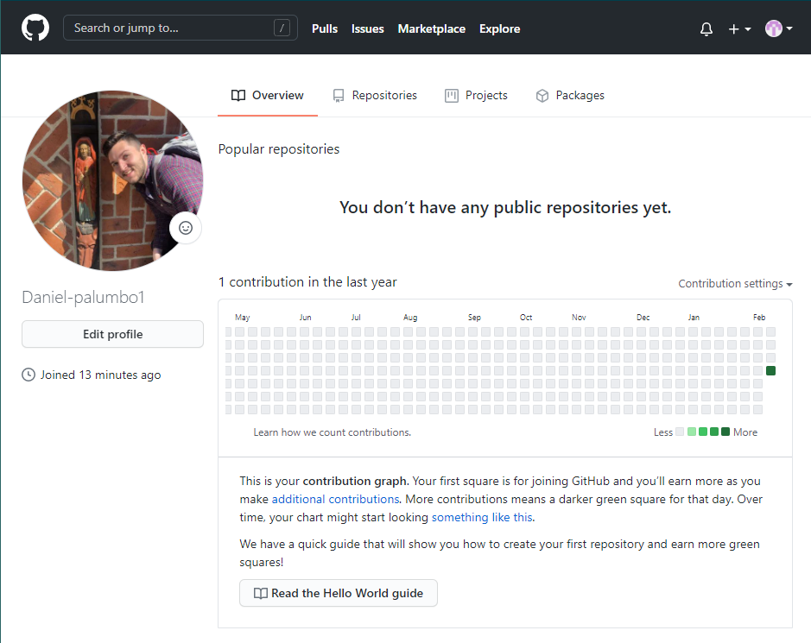

4 & 5). Git repo with HTTPS link before adding folders and Hw0

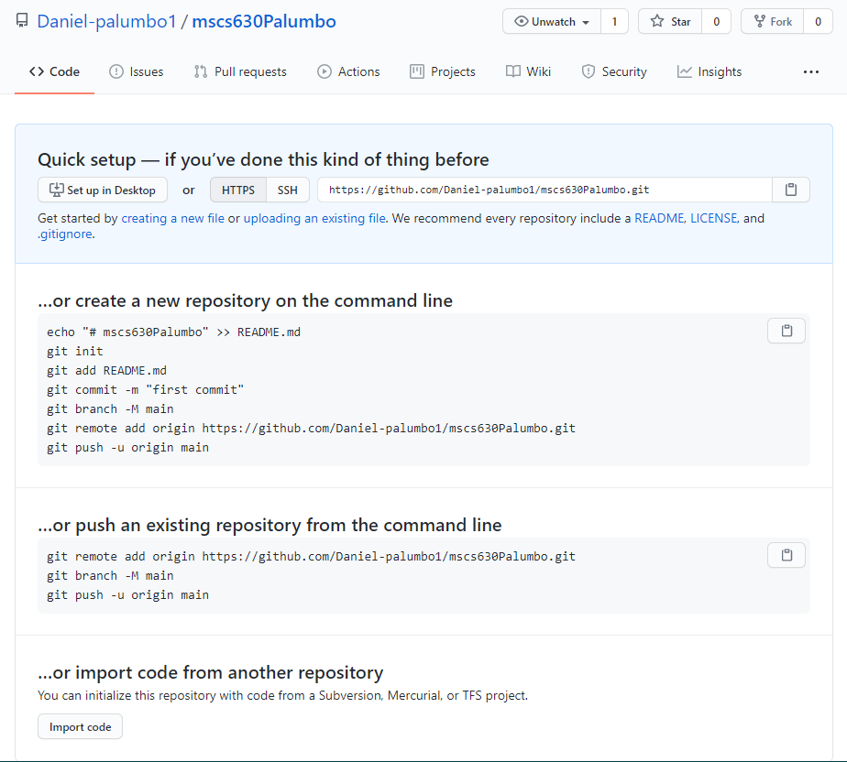

6.) Mirror pic for proof that I exist

